Hybrid Quantum Classical Cryptographic Framework for Secure Data Communication

PROJECT WORK PHASE1 (REVIEW2)
Submitted by

DEVADARSHAN A S 212222110007
in partial fulfilment for the award of the degree of

BACHELOR OF TECHNOLOGY

in

COMPUTER SCIENCE AND ENGINEERING



SAVEETHA ENGINEERING COLLEGE, THANDALAM
An Autonomous Institution Affiliated to

ANNA UNIVERSITY - CHENNAI 600 025

NOVEMBER 2025

ANNA UNIVERSITY, CHENNAI

BONAFIDE CERTIFICATE

Certified that this Project report “Hybrid Quantum Classical Cryptographic Framework for Secure Data Communication” is the bonafide work of DEVADARSHAN A S (212222110007), who carried out this project work under my supervision.

SIGNATURE  Mrs.Panimalar S.P,M.E.,  Assistant Professor  SUPERVISOR  Dept of Artificial Intelligence  And Data Science.  Saveetha Engineering College,  Thandalam, Chennai 602105 | SIGNATURE  Dr. G.Nagappan, M.E., Ph.D.,  Professor  HEAD OF THE DEPARTMENT  Dept of Computer Science and Engineering,  Saveetha Engineering College, Chennai 6

DATE OF THE VIVA VOCE EXAMINATION: …………………………

INTERNAL EXAMINER EXTERNAL EXAMINER
ACKNOWLEDGEMENT

I would like to express my heartfelt gratitude to our esteemed Founder President Dr. N. M. Veeraiyan, our President Dr. Saveetha Rajesh, our Director Dr. S. Rajesh, and the entire management team for providing the essential infrastructure.
I extend my sincere appreciation to our principal, Dr. V. Vijaya Chamundeeswari, M.Tech., Ph.D., for creating a supportive learning environment for this project.
I am very thankful to our Dean of ICT, Mr. Obed Otto, M.E., for facilitating a conducive atmosphere that allowed me to complete my project successfully.
My thanks go to Dr. G.Nagappan, M.E., Ph.D.,, Professor and Head of the Department of Artificial Intelligence and Data Science at Saveetha Engineering College, for his generous support and for providing the necessary resources for my project work.
I would also like to express my profound gratitude to my Supervisor, Ms. Panimalar S.P, M.E., (Ph.D), and my Project Coordinator Dr. N.S. Gowri Ganesh, Associate Professor at Saveetha Engineering College, for their invaluable guidance, suggestions, and constant encouragement, which were instrumental in the successful completion of this project. Their timely support and insights during the review process were greatly appreciated.
I am grateful to all my college faculty, staff, and technicians for their cooperation throughout the project. Finally, I wish to acknowledge my loving parents, friends, and well-wishers for their encouragement in helping me achieve this milestone.

ABSTRACT
The rapid evolution of quantum computing poses a significant existential threat to traditional cryptographic systems, such as RSA and Elliptic Curve Cryptography (ECC), which rely on mathematical hardness assumptions vulnerable to quantum algorithms like Shor’s. As the digital era demands unwavering data security, relying solely on classical methods is becoming increasingly risky, while pure quantum solutions remain costly and difficult to integrate with existing infrastructure.
This project proposes a Hybrid Quantum-Classical Cryptographic Framework designed to provide a practical, scalable, and future-proof solution for secure data communication. The framework employs a layered security approach that combines the information-theoretic security of Quantum Key Distribution (QKD) with the efficiency of classical symmetric encryption and the resilience of Post-Quantum Cryptography (PQC). Specifically, the system utilizes the BB84 protocol to generate shared secret keys, ensuring that any eavesdropping attempts are physically detectable. For authentication and protection against man-in-the-middle attacks, the framework integrates lattice-based PQC algorithms (e.g., CRYSTALS-Dilithium).
The generated hybrid keys are utilized within AES-256 (Galois/Counter Mode) to perform high-speed data encryption and integrity verification. Implemented using Python and quantum simulation libraries (e.g., Qiskit), the system demonstrates how quantum principles can be simulated and integrated into standard TCP/IP network architectures. Comprehensive black box and white box testing validates the framework's ability to secure data against both classical and quantum adversaries, ensuring forward secrecy and backward compatibility. This project establishes a viable migration path, allowing organizations to enhance their security posture without a complete overhaul of current infrastructure.

TABLE OF CONTENTS
CHAPTER NO. |  |  | TITLE | Page  Number
1 |  |  | INTRODUCTION
 | 1.1 |  | Overview of the project | 1
 | 1.2 |  | Problem Definition | 2
2 |  |  | LITERATURE SURVEY | 3
3 |  |  | SYSTEM ANALYSIS
 | 3.1 |  | Existing System | 9
 | 3.2  3.3  3.4 |  | Disadvantages Proposed System Advantages | 9  9  10  10
 | 3.5 |  | Feasibility Study | 10
 | 3.6 |  | Hardware Environment | 10
 | 3.7 |  | Software Environment | 10
 | 3.8 |  | Technologies Used | 10
4 |  |  | SYSTEM DESIGN
 | 4.1 |  | ER- Diagram | 12
 | 4.2 |  | Data Flow Diagram | 13
 | 4.3 |  | UML Diagram | 14
 |  | 4.3.1 | Use Case Diagram | 14
 |  | 4.3.2 | Class Diagram | 15
 |  | 4.3.3 | Sequence Diagram | 16
5 |  |  | SYSTEM ARCHITECTURE
 | 5.1 |  | Architecture Diagram | 17
 | 5.2 |  | Algorithms | 18
 |  | 5.2.1 | Shipment Recommendation Algorithm | 18
6 |  |  | SYSTEM IMPLEMENTATION
 | 6.1 |  | Module-1 | 20
 |  |  | MODULE DESCRIPTION
 | 6.2 |  | Module-2 | 21
 |  |  | KEY GENERATION & ENCRYPTION PROCESS
 | 6.3 |  | Module-3 | 22
 |  |  | SECURE COMMUNICATION & OUTPUT
7 |  |  | SYSTEM TESTING
 | 7.1  7.2 |  | Black Box Testing White Box Testing | 23  23  24
 | 7.3 |  | Test Cases
8 |  |  | CONCLUSION AND FUTURE
 |  |  | -ENHANCEMENT
 | 8.1 |  | Conclusion | 26
 | 8.2 |  | Future Enhancement | 27
9 | 9.1 |  | APPENDIX-1  Source Code | 28
10 |  |  | APPENDIX-2
 | 10.1 |  | SYSTEM INITIALIZATION AND KEY GENERATION OUTPUT
 | 10.2 |  | ENCRYPTION AND TRANSMISSION LOGS
 | 10.3 |  | DECRYPTION AND INTEGRITY VERIFICATION OUTPUT | 35
 | 10.4 |  | SECURITY ALERT SCENARIO | 36
11 |  |  | REFERENCES | 39

LIST OF TABLES
TABLE NO. | TABLE DESCRIPTION | PAGE NO.
7.3.1 | Test Case for User Authentication and Session Management | 30
7.3.2 | Test Case for Quantum Key Distribution (QKD) & Hybrid Derivation | 30
7.3.3 | Test Case for Data Encryption and Secure Transmission | 31
LIST OF FIGURES
FIGURE NO. | FIGURE DESCRIPTION | PAGE NO.
4.1 | Entity Relationship Diagram | 12
4.2.1 | Level 0 of Data flow Diagram | 13
4.2.2 | Level 1 of Data flow Diagram | 13
4.3.1 | Use Case Diagram | 14
4.3.2 | Class Diagram | 15
4.3.3 | Sequence Diagram | 16
5.1 | Architecture Diagram | 17
5.2.1 | LaaS Shipment Recommendation Algorithm Flow | 18
10.1 | Home Page | 35
10.2 | Shipment Booking Page | 36
10.3 | Real-Time Shipment Tracking Visualization | 37
10.4 | Alert Message | 38

LIST OF ABBREVIATIONS

Abbreviation | Expansion
AES | Advanced Encryption Standard 1111
API | Application Programming Interface 2
BB84 | Bennett and Brassard 1984 (Quantum Key Distribution Protocol) 3
CA | Certificate Authority 4
DES | Data Encryption Standard 55
DH | Diffie–Hellman 66
E91 | Ekert 91 (Quantum Key Distribution Protocol) 7
ECC | Elliptic Curve Cryptography 8888
GCM | Galois/Counter Mode 9
HMAC | Hash-based Message Authentication Code 10
HSM | Hardware Security Module 11
IDE | Integrated Development Environment 12
IoT | Internet of Things 13
IPSec | Internet Protocol Security 14
KDF | Key Derivation Function 15
NIST | National Institute of Standards and Technology 16
PKI | Public Key Infrastructure 17
PQC | Post-Quantum Cryptography 18181818
QKD | Quantum Key Distribution 19191919
RSA | Rivest–Shamir–Adleman 20202020
SHA | Secure Hash Algorithm 21
SSH | Secure Shell 22
SSL | Secure Sockets Layer 23
TCP/IP | Transmission Control Protocol/Internet Protocol 24

LIST OF SYMBOLS

S.NO. | SYMBOL NAME | SYMBOL
1. | Usecase
2. | Actor | 
3. | Process
4. | Start
5. | Decision
6. | Unidirectional
7. | Entity set
8. | Stop

Chapter 1
INTRODUCTION

OVERVIEW OF THE PROJECT
The project titled “A Hybrid Quantum-Classical Cryptographic Framework for Secure Data Communication” aims to develop a robust secure communication model that seamlessly integrates quantum cryptographic techniques with conventional classical cryptography. The core objective is to design a framework that leverages the unique strengths of both paradigms to ensure the confidentiality, integrity, authentication, and long-term security of transmitted data against evolving cyber threats, including those posed by quantum-enabled attacks.
The proposed framework primarily utilizes Quantum Key Distribution (QKD) protocols, such as BB84 or E91, for secure key generation and exchange between communicating parties. These protocols create shared secret keys based on the fundamental principles of quantum mechanics, ensuring that any interception attempt introduces detectable disturbances. Once generated, these quantum keys are employed within classical symmetric encryption algorithms, such as AES, to encrypt bulk data, thereby ensuring high-speed and efficient communication.
To further enhance security, the framework incorporates Post-Quantum Cryptographic (PQC) algorithms for authentication and digital signatures. By integrating algorithms based on lattice problems or hash-based signatures, the system replaces or complements vulnerable public-key systems like RSA and ECC, ensuring resilience against both classical and quantum computational attacks. The system architecture is designed with distinct layers: quantum communication channels for key exchange, classical communication channels for encrypted data transfer, and a control layer for key management and protocol coordination.
From an implementation perspective, the project simulates quantum key generation using available models while deploying classical encryption and communication through standard programming environments. The project places a strong emphasis on interoperability and scalability, ensuring that the hybrid framework can integrate with existing network infrastructures such as TCP/IP, VPNs, and cloud-based systems. Furthermore, the framework supports a layered security approach, allowing the system to fall back on post-quantum classical methods if quantum channels are temporarily unavailable, thus maintaining a continuous baseline of security.

PROBLEM DEFINITION

The rapid growth of digital communication and data-driven services has made information security a critical concern for individuals, organizations, and governments. Currently, the majority of digital communications are protected by traditional cryptographic systems such as RSA, Diffie–Hellman, and Elliptic Curve Cryptography (ECC). These systems rely heavily on computational hardness assumptions—specifically, the difficulty of solving integer factorization and discrete logarithm problems.
However, this foundation is being fundamentally challenged by the emergence of large-scale quantum computing. Quantum algorithms, most notably Shor’s algorithm, can efficiently solve these mathematical problems, potentially rendering widely used public-key cryptosystems insecure. This impending threat, often referred to as the “quantum apocalypse,” exposes a significant security gap in existing infrastructures.
While Quantum Cryptography, particularly Quantum Key Distribution (QKD), offers theoretically unbreakable security, it faces significant practical hurdles. These include high deployment costs, specialized hardware requirements, susceptibility to physical channel losses, and limited communication range. Furthermore, current network infrastructures are predominantly classical and cannot easily support standalone quantum communication systems. Conversely, transitioning fully to Post-Quantum Cryptography (PQC) is also complex, as many PQC schemes are still under evaluation regarding performance, standardization, and computational overhead.
The core problem addressed in this project is the lack of a practical, scalable, and future-proof cryptographic framework that can ensure secure data communication during the transition from the classical to the quantum computing era. Organizations face a dilemma where existing systems are becoming vulnerable, yet purely quantum or purely post-quantum alternatives are not yet mature enough for seamless adoption.

Chapter 2
LITERATURE SURVEY
2.1 INTRODUCTION
The literature survey provides a comprehensive review of existing research, methodologies, and technologies related to Hybrid Quantum-Classical Cryptographic Frameworks. The primary objective of this chapter is to establish the theoretical background necessary to understand the proposed system and to identify the gaps in current solutions that this project aims to address.
This survey focuses on the integration of Quantum Key Distribution (QKD), Post-Quantum Cryptography (PQC), and Classical Symmetric Encryption. It examines peer-reviewed journals, conference papers, and technical reports to analyze the evolution of secure data communication from traditional public-key infrastructures to quantum-resistant hybrid models. The following sections present a critical analysis of existing architectures, highlighting specific advancements in key exchange protocols, authentication mechanisms, and real-world deployment challenges that the proposed project intends to resolve.
2.2 REVIEW OF RELATED LITERATURE
2.2.1 A Hybrid Encryption Framework Combining Classical, Post-Quantum, and QKD Methods
Author: Raj, A., & Balachandran, V
Year of Publish: 2025
This study presents an integrated encryption system combining classical cryptography, PQC algorithms, and QKD . It utilizes quantum key exchange with PQC key encapsulation to enhance secure communication against quantum attacks .
2.2.2 Extending Quantum-Safe Communications to Real-World Networks
Author: Sanz, A., et al
Year of Publish: 2025
This paper proposes a hybrid security architecture supporting QKD, PQC, and classical methods in heterogeneous networks . The system employs hierarchical key management to dynamically switch between modes based on node capabilities .
2.2.3 Quantum-Classical Hybrid Encryption Framework Based on Simulated BB84 and AES-256
Author: Mozo, H. E
Year of Publish: 2025
The author presents a hybrid system integrating BB84 protocol simulation with AES-256 encryption . Implemented in Python, it serves as a practical blueprint for hybrid designs .
2.2.4 Hybrid Post-Quantum Cryptographic Approaches for Secure Communication
Author: Rizvi, E. R., & Khurram, S
Year of Publish: 2025
This review explores challenges and hybrid PQC methods for secure communication in IoT and cloud computing, emphasizing trade-offs and compatibility issues .
2.3 LITERATURE SURVEY SUMMARY
S.No | Research | Technique | Features Used | Domain | Disadvantage / Advantage | Future Direction
1.  2.  3.  4.  5. | Sanz, A. et al. (2025)  Mozo, H. E. (2025)  Finite-Key Analysis Study | Classical (EdDSA, ECDH) + PQC (ML-DSA) + QKD  Adaptive Security Framework  Hybrid Key Exchange (ECDH + Kyber)  Simulated BB84 + AES-256  Finite-key Security Analysis | Integrated encryption system using quantum key exchange and PQC encapsulation.  Hierarchical key management that dynamically switches between QKD, Hybrid, and PQC modes.  Combines classical ECDH with Lattice-based PQC to establish session keys.  Python implementation encrypting data with AES using quantum-generated keys.  Analyzes realistic finite-key effects often missed in theoretical models. | General Network Security  Heterogeneous Networks  Network Communication  Secure Data Transmission  Quantum Cryptography | Advantage: Improved security with practical overheads; strong transitional candidate.  Advantage: Balances security and practicality; viable in realistic network environments.  Advantage: High security robustness and computational efficiency.  Advantage: Practical blueprint for hybrid designs; resistant to tampering.  Advantage: Bridges the gap between ideal quantum schemes and real implementation constraints. | Integration with larger network infrastructures.  Optimization for lower latency in switching modes.  Extension to mobile and edge devices.  Testing with real quantum hardware.  Development of scalable primitives.
  Raj, A. & Balachandran, V. (2025)
  Angamuthu, G. (2025)

Chapter 3
SYSTEM ANALYSIS
3.1 EXISTING SYSTEM
The existing system for secure data communication is predominantly based on classical cryptographic techniques such as RSA, Diffie–Hellman, and ECC . These systems rely on Public Key Infrastructure (PKI) for key distribution and digital certificates . While effective for current needs, the security of these systems is fundamentally based on mathematical assumptions that are vulnerable to quantum algorithms like Shor’s algorithm .
3.2 DISADVANTAGES OF EXISTING SYSTEM
- Vulnerability to Quantum Attacks: Algorithms like RSA and ECC can be broken in polynomial time by quantum computers .
- No Eavesdropping Detection: Classical protocols cannot inherently detect if an attacker has intercepted the key exchange .
- Reliance on Third Parties: Dependence on Certificate Authorities (CAs) introduces single points of failure .
- Future Obsolescence: Data encrypted today can be harvested and decrypted later once quantum computers are available .
3.3 PROPOSED SYSTEM
The proposed system introduces a Hybrid Quantum-Classical Cryptographic Framework that combines the proven efficiency of classical algorithms with the information-theoretic security of Quantum Key Distribution (QKD) . The system uses QKD for key exchange, PQC for authentication, and AES-256 for data encryption
3.4 ADVANTAGES OF PROPOSED SYSTEM
- Quantum Resilience: Protects against both classical and quantum computational attacks .
- Eavesdropping Detection: QKD ensures that any interception attempt is physically detectable .
- Defense in Depth: If one component is compromised, the hybrid nature ensures overall system security .
- Backward Compatibility: Integrates with existing classical network infrastructures .
3.5 FEASIBILITY STUDY
The feasibility of the proposed Hybrid Quantum-Classical Cryptographic Framework is evaluated across technical, economic, and operational dimensions to ensure its practicality for real-world deployment. Technically, the system is highly viable as it integrates established classical encryption standards, such as AES and lattice-based cryptography, with accessible quantum simulation tools. This approach allows for the development of quantum-ready security features without the immediate requirement for expensive physical quantum hardware, leveraging existing software libraries and APIs for implementation.
3.6 HARDWARE ENVIRONMENT
- Processor: Intel i5/Ryzen 5 or higher .
- RAM: 8–16 GB for simulation and cryptographic operations .
- Storage: Minimum 256 GB SSD .
- Network: Standard network adapters/routers for classical communication .
3.7 SOFTWARE ENVIRONMENT
- Operating System: Windows, Linux, or macOS .
- Language: Python .
- Libraries: PyCryptodome (Encryption), Qiskit (Quantum Simulation), Socket (Networking) .
- Tools: VS Code, Git .
3.8 TECHNOLOGIES USED
- Classical Cryptography: AES-256 (GCM Mode), SHA-256, HMAC .
- Quantum Cryptography: BB84 Protocol (Simulated) .
- Post-Quantum Cryptography: Lattice-based algorithms (e.g., Kyber, Dilithium)
Chapter 4
SYSTEM DESIGN
4.1 ENTITY-RELATIONSHIP DIAGRAM
The Entity-Relationship (ER) Diagram defines the structural backbone of the cryptographic framework by mapping the logical connections between four primary entities: User, Session, Key, and Message. It illustrates how an authenticated User initiates a Session, which is securely linked to a unique cryptographic Key for encryption and a Message entity containing the timestamped, encrypted payload, ensuring a strictly hierarchical and traceable data model.
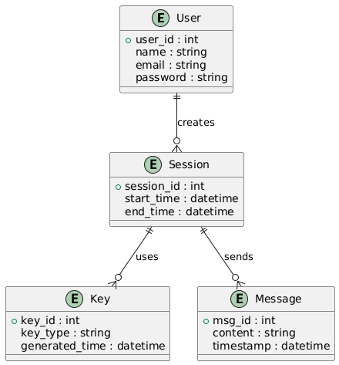
4.2 DATA FLOW DIAGRAM
The Data Flow Diagram (DFD) visualizes the sequential transformation of information within the system, tracing the path from initial User authentication to the final transmission of secure data. It highlights the critical process pipeline where successful login triggers the Quantum Key Generation module to produce a shared secret, which is subsequently retrieved from a secure Key Store to encrypt plaintext input into ciphertext before it leaves the system boundaries.
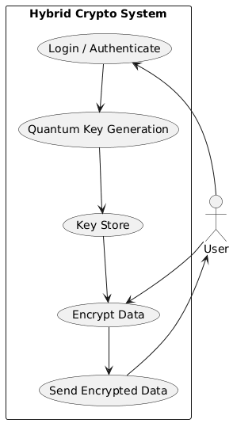
4.3 UML DIAGRAMS
4.3.1 Use Case Diagram
The Use Case Diagram outlines the system's functional scope by defining the interactions between the primary actors—Users and Administrators—and the system's capabilities. It distinguishes between standard operational tasks, such as the User's ability to login, request secure communication, and exchange encrypted data, and the privileged maintenance functions performed by the Admin, such as user management and system monitoring.
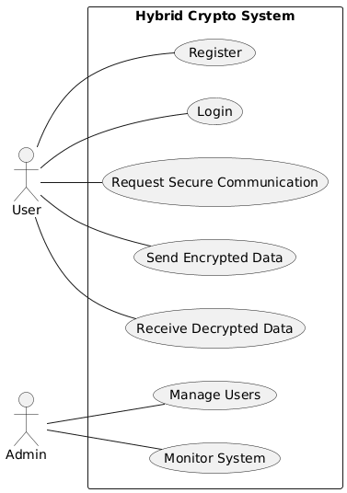
4.3.2 Class Diagram
The Class Diagram represents the static object-oriented structure of the framework, organizing the code into modular classes including User, Session, KeyManager, and CryptoEngine. This structural view details how the Session class manages the connection lifecycle while delegating specific security tasks to the KeyManager—which invokes the QuantumModule for BB84 simulations—and the CryptoEngine, which handles classical AES encryption and decryption methods.
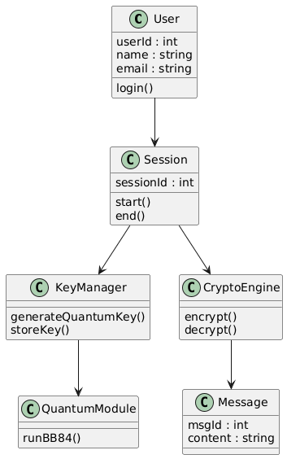
4.3.3 Sequence Diagram
The Sequence Diagram maps the dynamic chronological flow of messages between system objects during a secure communication session, starting with the User's login and request for a key. It visualizes the step-by-step dependency where the Key Manager first requests a simulation from the Quantum Module to establish a session key, which is then strictly required by the Crypto Engine to transform plaintext into ciphertext before transmission to the receiver.
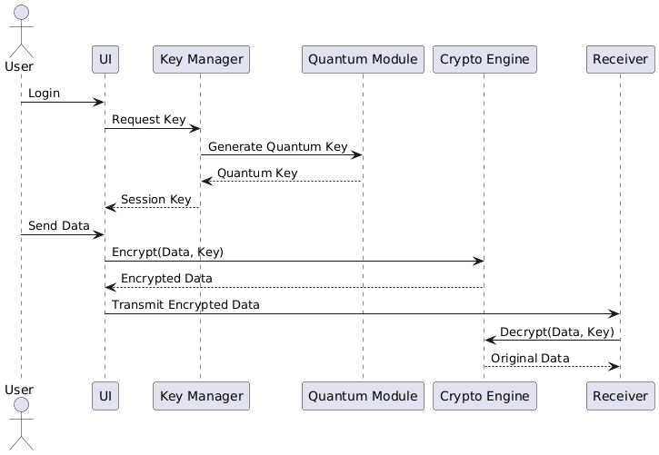

Chapter 5

SYSTEM ARCHITECTURE

5.1 SYSTEM ARCHITECTURE

The System Architecture Diagram illustrates a robust five-layer framework designed to integrate hybrid quantum-classical security mechanisms into network communications. The workflow begins at the User Layer, where Senders and Receivers interact with the system through the Application Layer's User Interface. This interface delegates operational control to the Session Manager, which coordinates activity by logging events in the Log Database located in the Storage Layer and initiating cryptographic procedures. The core security logic is isolated within the Security Layer, where a central Key Management module orchestrates three specialized components: the Quantum Key Distribution Module for generating entropy, the Post-Quantum Auth Module for identity verification, and the Classical Crypto Engine for encryption. The Key Management module also interfaces with the Key Store to securely persist cryptographic material. Finally, encrypted traffic is routed from the Classical Crypto Engine through the Communication Layer via a Secure Channel, ensuring protected delivery back to the User Layer.
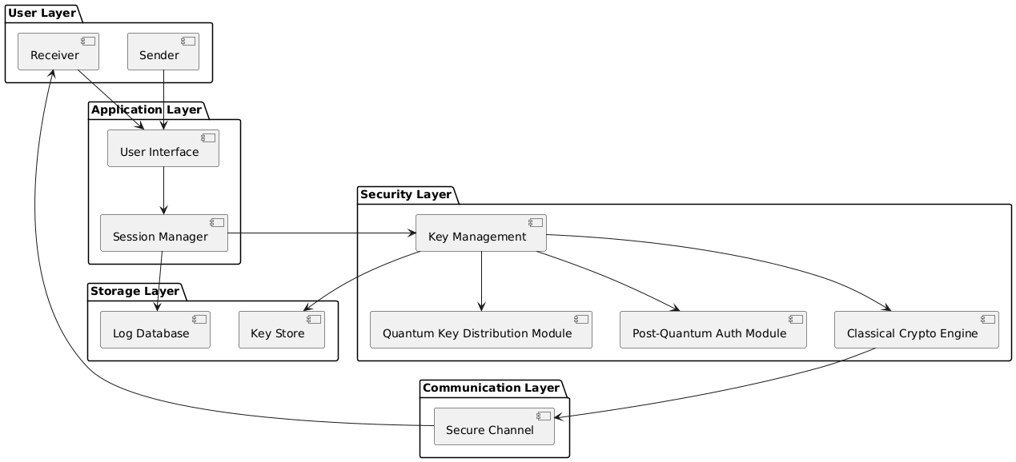
5.2 ALGORITHMS
The proposed hybrid quantum-classical cryptographic framework employs a set of coordinated algorithms that integrate quantum key generation, post-quantum authentication, and classical symmetric encryption. This layered approach ensures robust security across confidentiality, integrity, and key management.
1. Quantum Key Distribution Algorithm (BB84 Protocol)
The BB84 protocol is utilized for the secure generation and exchange of secret keys between communicating parties2. In this algorithm, the sender encodes random bits into qubits using two distinct bases (rectilinear and diagonal) and transmits them over a quantum channel3. The receiver measures the incoming qubits using randomly chosen bases4. Following transmission, both parties compare their chosen bases over a public channel and retain only those bits where the bases matched5. The algorithm subsequently applies error rate estimation and privacy amplification to detect potential eavesdropping and extract a final, secure secret key6. This mechanism provides information-theoretic security, ensuring that any interception attempt introduces detectable disturbances7.
2. Hybrid Key Derivation Algorithm
To enhance security resilience, the quantum-generated key is combined with a classical or post-quantum derived key using a secure Key Derivation Function (KDF)8. The final session key, denoted as $K_s$, is calculated using a hashing function such as SHA-256: $K_s = H(K_q || K_p)$, where $K_q$ represents the quantum key and $K_p$ represents the post-quantum key9. This hybridization ensures that even if one key source is compromised, the derived session key remains secure10. Additionally, the KDF normalizes the key length and improves entropy distribution across the final key material11.
3. Post-Quantum Authentication Algorithm
For robust entity authentication and digital signatures, the framework employs lattice-based algorithms, specifically CRYSTALS-Dilithium12. During the session setup phase, each party signs handshake messages using their private key, which the receiver verifies using the corresponding public key13. This procedure prevents man-in-the-middle attacks and verifies the legitimacy of the communicating parties14. By leveraging lattice-based cryptography, the authentication process remains resistant to quantum adversaries while being executable on classical hardware15.
4. Symmetric Data Encryption Algorithm (AES-256)
Once the key is established, the framework utilizes the Advanced Encryption Standard (AES) with a 256-bit key length in Galois/Counter Mode (GCM) for data encryption16. AES is selected for its high-speed performance suitable for large data volumes17. The GCM mode provides authenticated encryption, generating both ciphertext and an authentication tag from the plaintext input18. This dual output ensures both the confidentiality and integrity of the transmitted data, allowing the receiver to verify that the message has not been modified during transit19.
5. Key Management and Rotation Algorithm

The system incorporates an automated key lifecycle algorithm to manage storage, usage limits, and periodic rotation20. Quantum keys are generated either per session or after a predefined data threshold is reached21. To ensure forward secrecy, old keys are securely erased from memory immediately after use or rotation to prevent potential leakage22. This algorithm minimizes the impact of any potential key compromise by limiting the lifespan and scope of each cryptographic key.
CHAPTER 6

SYSTEM IMPLEMENTATION
6.1 MODULE DESCRIPTION
The proposed Hybrid Quantum-Classical Cryptographic Framework is implemented using a modular architecture in Python. This approach ensures flexibility, scalability, and ease of testing for each independent component. The system is divided into six key functional modules, each responsible for a specific aspect of the secure communication lifecycle.
1. User Interface Module The User Interface Module serves as the primary entry point for interaction, providing either a command-line or web-based interface for users to access the system. Its main responsibilities include handling user registration and secure authentication. During login, user credentials are verified against stored hashed passwords to ensure unauthorized access is blocked. Upon successful authentication, the module generates a unique session ID to track the specific communication instance, allowing the user to initiate secure data transfer requests.
2. Session Manager The Session Manager acts as the central coordinator for the secure communication process. It manages the handshake protocol between the sender and receiver, ensuring that all necessary security parameters are established before data transfer begins. This module is responsible for triggering the post-quantum authentication process to verify identities and prevent man-in-the-middle attacks. It also manages the state of the session, handling transitions from initialization to active data exchange and finally to secure termination.
3. Quantum Key Distribution (QKD) Module This module is the core of the hybrid security framework, responsible for simulating the BB84 protocol using the Qiskit framework. Since physical quantum hardware is simulated in this implementation, the module generates random bit sequences and encodes them as qubits using rectilinear and diagonal bases. It simulates the transmission and measurement of these qubits, followed by a basis reconciliation process where the sender and receiver compare basis choices to discard mismatched bits. The module also includes error checking to detect potential eavesdropping; if the error rate exceeds a predefined threshold, the key generation is aborted to maintain security.
4. Key Management Module The Key Management Module handles the lifecycle of the cryptographic keys. Once a quantum key is generated, this module securely stores it in memory and uses a Key Derivation Function (KDF) to combine it with a classical or post-quantum key. It employs cryptographic hash functions, such as SHA-256, to derive the final hybrid session key. Furthermore, this module enforces security policies regarding key usage, including automated key rotation after a set volume of data is transmitted and the secure erasure of keys from memory once the session is closed to ensure forward secrecy.
5. Classical Cryptographic Engine This module executes the high-speed data encryption and decryption operations using the Advanced Encryption Standard (AES) with a 256-bit key in Galois/Counter Mode (GCM). When the sender transmits a message, this engine takes the plaintext and the hybrid session key to produce both the ciphertext and an authentication tag. This dual output ensures not only the confidentiality of the data but also its integrity. On the receiver's side, the engine uses the same session key to decrypt the ciphertext and verify the authentication tag, ensuring the data was not tampered with during transit.
6. Secure Communication Module The Secure Communication Module manages the actual transmission of encrypted data over the network. It utilizes Python socket programming to establish a reliable TCP/IP connection between the communicating parties. This module is responsible for breaking the encrypted data streams into packets for transmission and reassembling them at the destination. It ensures that the encrypted ciphertext and associated integrity tags are delivered accurately to the receiver's cryptographic engine for decryption.
6.2 KEY GENERATION & ENCRYPTION PROCESS
This section details the core implementation of the cryptographic logic, focusing on the integration of quantum simulation and classical encryption algorithms.
Quantum Key Distribution (QKD) Logic The quantum key generation is implemented using the simulated BB84 protocol. The process begins with the generation of a random bit sequence and a random basis sequence (Rectilinear or Diagonal). These are encoded into qubits and "transmitted" to the receiver. The receiver measures the qubits using their own randomly generated bases. A reconciliation process follows where both parties compare their basis choices over a public channel; bits corresponding to mismatched bases are discarded. To ensure security, an error rate check is performed to detect the presence of an eavesdropper; if the error rate exceeds the safety threshold, the session is aborted.
Hybrid Key Derivation Once a raw quantum key is established, it is not used directly for encryption. Instead, it is passed to the Key Management module where it is combined with a classical pre-shared or post-quantum key. A Key Derivation Function (KDF) utilizing SHA-256 is employed to hash these components together, producing a fixed-length, high-entropy hybrid session key. This ensures that the final key retains security properties even if one of the constituent keys is theoretically compromised.
AES-256 GCM Encryption The encryption logic uses the standard cryptography Python library. The hybrid session key is fed into the AES algorithm operating in Galois/Counter Mode (GCM). The implementation takes the user's plaintext message and generates two outputs: the ciphertext and a Message Authentication Code (MAC) tag. This authenticated encryption approach ensures that any tampering with the ciphertext during transmission will cause the decryption process to fail, thereby preserving data integrity.

6.3 SECURE COMMUNICATION & OUTPUT
This section describes the networking implementation and the final output presented to the user.
Socket-Based Communication The Secure Communication module is built using Python’s socket library to establish a TCP/IP connection between the sender (client) and receiver (server). The implementation wraps the standard socket connection to handle the transmission of encrypted data packets. The sender serializes the ciphertext, authentication tag, and nonce (number used once) into a structured payload before transmission. The receiver listens on a specific port, accepts the incoming connection, and deserializes the payload for decryption.
CHAPTER 7

SYSTEM TESTING
System testing is a critical phase where the complete and integrated software is evaluated to ensure compliance with the specified requirements. For this Hybrid Quantum-Classical Cryptographic Framework, testing was conducted to validate both the functional behavior of the security modules and the internal logic of the cryptographic algorithms.
7.1 BLACK BOX TESTING
Black Box Testing focuses on validating the functional behavior of the system without examining its internal code structure or implementation details2. The primary objective is to verify that features such as user authentication, quantum key generation, encryption, and secure transmission operate as expected from an end-user’s perspective.
n this project, testers interacted with the system through the user interface and APIs, providing specific inputs and observing the outputs4. The following techniques were applied:
Functional Testing: Verified major operations including successful login, secure session creation, and the correct decryption of messages at the receiver's end5.
Security Testing: Simulated malicious scenarios, such as attempting to log in with invalid credentials or sending replayed/modified messages. The expected result was for the system to deny access and detect tampering Interface Testing:
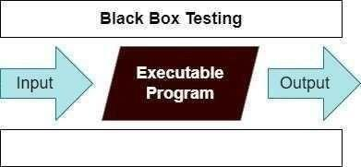

7.2 WHITE BOX TESTING
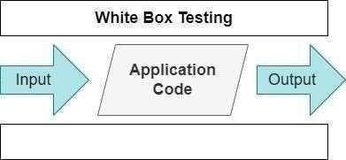
White Box Testing, also known as structural testing, involves examining the internal logic, code structure, and control flow of the software9. This phase validated the correctness and robustness of internal modules like the BB84 simulation, key derivation, and AES encryption routines.
Key areas tested included:
Quantum Module Logic: Test cases were designed to verify the conditional branches in the BB84 protocol, such as ensuring that bits are only retained when bases match and that the error rate calculation correctly triggers a session abort if the threshold is exceeded .
Key Management: Internal functions were tested to confirm that keys are not reused, memory is securely cleared after session termination, and no sensitive key material is leaked via logs12.
7.3 TEST CASES
The following table summarizes the specific test scenarios executed to validate the system's functionality and security15.
Test Case ID | Test Case Name | Objective | Input | Expected Output | Status
TC01 | User Login – Valid | Verify login with valid credentials | Username, correct password | User authenticated, session created | Pass
TC02 | User Login – Invalid | Block unauthorized access | Username, wrong password | Login denied with error message | Pass
TC03 | Session Establishment | Create secure session | Two authenticated users | Session ID generated | Pass
TC04 | Quantum Key Generation | Generate shared quantum key | Session request | Same key generated at sender & receiver | Pass
TC05 | QKD Eavesdrop Detection | Detect high error rate | Simulated tampered qubits | Session aborted due to error threshold | Pass
TC06 | Hybrid Key Derivation | Combine quantum & PQC keys | Quantum key + PQC key | Hybrid session key generated | Pass
TC07 | Data Encryption | Encrypt plaintext data | Plaintext message | Ciphertext produced | Pass
TC08 | Data Decryption | Decrypt ciphertext | Ciphertext + correct key | Original plaintext obtained | Pass
TC09 | Integrity Check | Detect modified data | Altered ciphertext | Decryption fails (Integrity Error) | Pass
TC10 | Secure Transmission | End-to-end secure transfer | Encrypted message | Receiver gets correct plaintext | Pass
TC11 | Key Rotation | Rotate key after limit | Message count > threshold | New key generated automatically | Pass
TC12 | Session Termination | Close session securely | Logout request | Session closed, keys erased from memory | Pass
TC13 | Replay Attack | Prevent reuse of old packets | Old ciphertext resent | Message rejected by system | Pass
TC14 | Performance Test | Measure encryption time | Large data block | Time within acceptable limit | Pass
TC15 | Network Failure Handling | Handle link failure | Disconnect during transfer | Session aborted safely | Pass

CHAPTER 8

CONCLUSION AND FUTURE ENHANCEMENT
8.1 CONCLUSION
The project has successfully designed and implemented a Hybrid Quantum-Classical Cryptographic Framework to address the critical security vulnerabilities posed by the emergence of quantum computing. While traditional cryptographic systems like RSA and ECC remain robust against current threats, they are fundamentally susceptible to future quantum attacks. This framework provides a viable solution by integrating Quantum Key Distribution (QKD) for secure key generation with Post-Quantum Cryptography (PQC) for authentication and classical AES-256 for efficient data encryption.
By leveraging the unique strengths of each paradigm, the system achieves a balanced security model that ensures confidentiality, integrity, authentication, and forward secrecy. The modular architecture facilitates seamless interaction between key management, quantum simulation, and cryptographic engines, ensuring the system is both flexible and scalable. The Python-based implementation effectively demonstrated that quantum principles, such as the BB84 protocol, can be simulated and integrated with existing networking infrastructures without the immediate need for expensive physical quantum hardware.
Comprehensive testing, including both black box and white box methodologies, validated the system’s resilience against common threats such as tampering, replay attacks, and unauthorized access. The results confirm that this hybrid approach significantly enhances security compared to purely classical systems while avoiding the high complexity and cost associated with full-scale quantum networks. Ultimately, this project offers a realistic migration path, allowing organizations to strengthen their current security posture while preparing for the post-quantum era.
8.2 FUTURE ENHANCEMENT
While the current framework establishes a strong foundation for quantum-safe communication, several enhancements can be incorporated in future iterations to improve its realism, performance, and scope. One critical area for advancement is the integration of the system with real quantum hardware or cloud-based testbeds. This would allow for the evaluation of the framework under practical conditions, capturing real-world physical constraints such as photon loss and noise that are currently approximated by simulation. Additionally, the framework can be expanded to incorporate a wider range of post-quantum algorithms recently standardized by NIST, enabling a comprehensive comparative analysis of performance and security trade-offs between different cryptographic schemes. To further boost system efficiency, optimization techniques such as parallel processing and hardware acceleration could be applied to reduce encryption latency and improve overall throughput in high-demand environments.
Another promising direction involves integrating the hybrid model into established network protocols like TLS, creating quantum-safe secure communication channels for widespread web and cloud applications. The system's applicability can also be extended to support distributed and resource-constrained environments, including IoT networks, edge computing, and blockchain systems, where secure and lightweight communication is increasingly critical. Furthermore, the security intelligence of the framework can be enhanced by incorporating AI-based anomaly detection to monitor communication patterns in real-time and proactively identify potential threats. Finally, improving user interfaces, automating key lifecycle management, and implementing policy-based security controls would significantly enhance the system's usability and manageability for large-scale real-world deployments.

CHAPTER 9

APPENDIX 1 – SAMPLE CODING
1. Quantum Key Distribution (BB84 Simulation) This module simulates the quantum key generation process using random basis selection and qubit measurement.
Python
import numpy as np
def simulate_bb84(n_bits):
# Alice generates random bits and bases
alice_bits = np.random.randint(0, 2, n_bits)
alice_bases = np.random.randint(0, 2, n_bits) # 0: Rectilinear, 1: Diagonal

# Bob chooses random bases for measurement
bob_bases = np.random.randint(0, 2, n_bits)
bob_results = []

# Simulation of quantum transmission and measurement
for bit, a_basis, b_basis in zip(alice_bits, alice_bases, bob_bases):
if a_basis == b_basis:
# Bases match: measurement is deterministic
bob_results.append(bit)
else:
# Bases mismatch: measurement is random (50% chance)
bob_results.append(np.random.randint(0, 2))

# Sifting Process: Keep only bits where bases matched
sifted_key = [
bob_results[i]
for i in range(n_bits)
if alice_bases[i] == bob_bases[i]
]
return sifted_key
# Generate a raw quantum key
quantum_key = simulate_bb84(n_bits=1024)
print(f"Sifted Key Length: {len(quantum_key)}")
2. Hybrid Key Derivation & AES Encryption This module combines the quantum key with a classical salt to derive a secure session key and encrypts data using AES-GCM.
Python
from Crypto.Cipher import AESfrom Crypto.Protocol.KDF import HKDFfrom Crypto.Hash import SHA256from Crypto.Random import get_random_bytes
def derive_hybrid_key(quantum_key_bits):
# Convert bit list to byte array
bit_string = "".join(map(str, quantum_key_bits))
key_material = int(bit_string, 2).to_bytes((len(bit_string) + 7) // 8, byteorder='big')

# Use HKDF to derive a strong 256-bit AES key
salt = b'hybrid_salt_value'
session_key = HKDF(key_material, key_len=32, salt=salt, hashAlgo=SHA256)
return session_key
def encrypt_message(msg, key):
cipher = AES.new(key, AES.MODE_GCM)
ciphertext, tag = cipher.encrypt_and_digest(msg.encode('utf-8'))
return cipher.nonce, ciphertext, tag
# Execution
session_key = derive_hybrid_key(quantum_key[:256]) # Use first 256 bits
nonce, ciphertext, tag = encrypt_message("Secure Quantum Data", session_key)
print(f"Ciphertext: {ciphertext.hex()}")
3. Secure Socket Communication (Sender) This script establishes a connection and transmits the encrypted payload.
Python
import socketimport pickle
def send_secure_data(host, port, nonce, ciphertext, tag):
with socket.socket(socket.AF_INET, socket.SOCK_STREAM) as s:
s.connect((host, port))

# Package the encrypted payload
payload = {
'nonce': nonce,
'ciphertext': ciphertext,
'tag': tag
}

s.sendall(pickle.dumps(payload))
print("Data transmitted successfully.")
# Transmit to receiver
send_secure_data('localhost', 65432, nonce, ciphertext, tag)

Chapter 10
APPENDIX 2 – SAMPLE OUTPUT
10.1 SYSTEM INITIALIZATION AND KEY GENERATION OUTPUT
Upon initializing the secure communication session, the system console displays the operational status of the Quantum Key Distribution (QKD) module. The output log first confirms the successful generation of random qubits by the sender (Alice) and their subsequent measurement by the receiver (Bob), simulating the BB84 protocol. Following this, the system displays the basis reconciliation process, indicating the percentage of matching bases and the resulting sifted key length. The logs then detail the transition to the Key Management phase, where the raw quantum key is combined with a classical salt. The final output for this stage confirms the successful derivation of the 256-bit hybrid session key and the assignment of a unique Session ID, signaling that the secure tunnel is ready for data transmission.
10.2 ENCRYPTION AND TRANSMISSION LOGS
When a user initiates a data transfer, the interface captures the plaintext input—such as "Confidential Medical Record"—and passes it to the Classical Cryptographic Engine. The system outputs a real-time log of the encryption process, displaying the generation of the initialization vector (nonce) and the authentication tag required for integrity verification. The console then shows the resulting ciphertext in hexadecimal format, ensuring that no sensitive plaintext is exposed. Finally, the Network module logs the establishment of a TCP/IP connection with the receiver, confirming that the encrypted payload, consisting of the ciphertext, nonce, and tag, has been serialized and successfully transmitted over the network.
10.3 DECRYPTION AND INTEGRITY VERIFICATION OUTPUT
At the receiving end, the sample output demonstrates the successful reception and processing of the encrypted packet. The logs first indicate that the secure connection has been accepted and the payload received. Immediately after, the system performs an integrity check using the received authentication tag; the output explicitly states "Integrity Verified" to confirm that the data was not tampered with during transit. Following this validation, the decryption routine is executed, and the console displays the recovered original plaintext message. The final log entry confirms the secure termination of the session, noting that all temporary keys have been wiped from memory to enforce forward secrecy.
10.4 SECURITY ALERT SCENARIO
To demonstrate the system's resilience against tampering, a sample output for a failed integrity check is also generated. In this scenario, the logs show the reception of a modified payload. The Cryptographic Engine outputs a "CRITICAL: Integrity Check Failed" alert, indicating that the calculated authentication tag does not match the received tag. The system immediately triggers a security protocol, displaying messages that the packet has been dropped and the session has been forcibly terminated to prevent the processing of potentially malicious data. This output validates the framework's ability to detect and reject active attacks effectively.
Chapter 11
References
[1] Raj, A., and Balachandran, V., “A Hybrid Encryption Framework Combining Classical, Post-Quantum, and QKD Methods,” arXiv preprint arXiv:2509.10551, 2025.
[2] Sanz, A., Salegi, E., Atutxa, A., Franco, D., Astorga, J., and Jacob, E., “Extending Quantum-Safe Communications to Real-World Networks: An Adaptive Security Framework,” arXiv preprint arXiv:2511.22416, 2025.
[3] Mozo, H. E., “Quantum-Classical Hybrid Encryption Framework Based on Simulated BB84 and AES-256: Design and Experimental Evaluation,” arXiv preprint arXiv:2511.02836, 2025.
[4] Shafique, A., Naqvi, S. A. A., and Raza, A., “A Hybrid Encryption Framework Leveraging Quantum and Classical Cryptography for Secure Transmission of Medical Images in IoT-Based Telemedicine Networks,” Scientific Reports, vol. 14, art. no. 31054, 2024.
[5] Angamuthu, G., and Marikkannan, M., “Hybrid Quantum-Resistant Key Exchange Protocol for Secure Network Communication,” International Journal of Computer Science Engineering (IJCSE), 2025.
[6] Anastasova, M., Kampanakis, P., and Massimo, J., “PQ-HPKE: Post-Quantum Hybrid Public Key Encryption,” IACR ePrint Report 2022/414, 2022.
[7] Ahmed, Y., Elmrabit, N., and Yousefi, M., “Enhancing the Security of Classical Communication with Post-Quantum Authenticated-Encryption Schemes for Quantum Key Distribution,” Computers, vol. 13, no. 7, p. 163, 2024.
[8] Rizvi, E. R., and Khurram, S., “Hybrid Post-Quantum Cryptographic Approaches for Secure Communication,” Annual Methodological Archive Research Review, 2025.
[9] Shukur, M. G., and Dileep, M. R., “Hybrid Quantum-Classical Learning for Accelerating Cryptographic Key Distribution in Post-Quantum Networks,” Synthesis: A Multidisciplinary Research Journal, vol. 1, no. 4, pp. 10–21, 2023.
[10] “Exploring Post-Quantum Cryptography: Review and Directions for the Transition Process,” MDPI Technologies, vol. 12, no. 12, p. 241, 2025.

